|  |  |  |  |  |  |  |
| --- | --- | --- | --- | --- | --- | --- |
| **School of Computer Science & Software Engineering**  Bachelor of Computer Science (Digital Systems Security) | | | | | | |
|  | CSCI321- Project  Technical Manual | | | |  | |
|  | Group: SS18-4B | | | |  | |
|  | Hidir Ibrahim | 5920620 | | muhammad683@mymail.sim.edu.sg | |  |
|  | Nitisha Venkatachari | 5283048 | | vp001@mymail.sim.edu.sg | |  |
|  | Eustacia Lim You Yan | 5922173 | | yyelim001@mymail.sim.edu.sg | |  |
|  | | |  | | | |
|  | | | Supervisor: Dr Ta Nguyen Binh Duong | | | |
|  | | | Assessor: Prof Tan Kheng Teck | | | |

Table of Contents

Document Control 4

Roles 4

Record of Revision 4

Executive Summary 5

Introduction 5

Project Description 6

Background 6

Solution 6

Objectives 6

Visual Cryptography Algorithm 8

Arguments 8

Initialization 8

Pixel Traversing & New Image Transformation 8

Algorithm of New Image Transform 8

Limitations 10

Limitation 1: Short of Manpower 10

Limitation 2: No mainstream uses of Visual Cryptography 10

Limitation 3: Application Reliant on User’s Email Security 10

Application Requirements 11

Component 1: Frontend Website 11

Component 2: Backend Website 12

Component 3: Image Processor 13

Component 4: Database 14

Risk Management 15

Gantt Chart 16

Project Website 16

Use Case Diagram 17

Iteration 1 17

Iteration 2 18

Detailed Use Case 19

Workflow Diagram 32

Add Admin 32

Delete Admin 33

Edit Admin 34

Create Subject 35

Delete Subject 36

Edit Subject 37

Create New Critical Section 38

Delete Critical Section 39

Edit Critical Section 40

Sequence Diagram 41

Iteration 1 41

User Interface 42

Front End 42

Admin Menu 43

Manage Website Content 44

Manage Subject 45

Edit Subject 46

Create Subject 47

Subject Created 48

Subject Deleted 49

Manage Admins 50

Create New Admins 50

Update Admin’s Username & Password 51

Delete Admin 51

Verification 52

Manage Critical Section 55

Add New Critical Section 55

Update New Critical Section 56

Delete Critical Section 56

Development Methodology 57

Test Cases 58

Development Tools 68

Main Stack 68

External Libraries Used 69

## Document Control

Title: Secure Remote Authentication using Visual Cryptography

|  |  |  |  |
| --- | --- | --- | --- |
| **Owner** | **Current Version** | **Last Modified** | |
| Hidir Ibrahim  Nitisha Venkatachari  Eustacia Lim You Yan | 1.0 | **Date** | **Time** |
| 05/12/2018 | 0100 |

## Roles

|  |  |
| --- | --- |
| **Name** | **Role** |
| Hidir Ibrahim | Project Leader |
| Nitisha Venkatachari | Lead Designer |
| Eustacia Lim You Yan | Lead Developer |

## Record of Revision

|  |  |  |  |  |
| --- | --- | --- | --- | --- |
| **Revision Date** | **Description** | **Section Affected** | **Changes Made By** | **Version** |
| 5/12/2018 | Document Created | All | Everyone | 1.0 |
| 30/12/2018 | Modification of document | Detailed Use Case  Gantt Chart | Everyone | 1.1 |
| 20/2/2019 | Added Test Cases & Updated Stack List | Development Tools  Test Cases | Everyone | 1.2 |
| 27/2/2019 | Modification of Document | Workflow Diagram, Use Case Diagram, Interfaces | Everyone | 1.3 |
| 1/3/2019 | Modification of Document | Standardize the document | Everyone | 1.4 |

## Executive Summary

The aim of this project is to increase security to a website/application by providing an additional authentication method on top of the traditional password protocol for logging in the user by utilizing Visual Cryptography.

## Introduction

Our team feels that the current mainstream method of a single password-based authentication is not enough to fulfil the security needs of websites today. Our team proposes an additional authentication-method on top of a password to further improve security.

With this documentation, we aim to make clear:

* Problems with a single-authentication based protocol
* Our proposed way of providing authentication using Visual Cryptography

This documentation will also cover these topics in the following order

* Reasons for proposing this project
* Existing applications/proposals of Visual Cryptography
* Our Application Objectives & Requirements
* Development Methods
* Roles & Timetable

## Project Description

### Background

In today’s high technology environment, IT has become an indispensable part of any enterprise or organization. Accurate business planning, effective marketing, and long-term business growth at the optimum level is impossible to achieve without IT. As such, organizations are becoming more and more dependent on their information systems.   
  
People are increasingly concerned about the proper use of information, especially personal data. Many organizations will identify information as an area of their operations that needs to be protected as part of their system of internal control. Unfortunately, cyber criminals like unethical hackers are now more common, and the threat of organization getting crucial and confidential data stolen is very real.

On the other side of things, single-factor authentication is the simplest form of authentication methods. Most verification today uses only password as an authentication method.   
  
However, there are many users who are still using weak passwords for their work accounts and email accounts. Many even use the same password for all their accounts, as it is more convenient for them to remember. This makes it much easier for cyber criminals to access their accounts and all the information that is available. If one’s get compromised, it could cost thousands of dollars and irreversible damage for the organization.

### Solution

To solve the current situation, we have come up with the idea of enhancing authentication by implementing two-factor authentication using Visual Cryptography. Visual Cryptography hides secret within the images, images transformed into multiple shares and decoding is done by stacking the share which will reveal the secret image or text. For the user to login into the account, the user required password and registered email access to retrieve the shares that is sent to the user to complete the login process.

Notable critical sections of the systems are registered in the database by name. If authorized users wish to access one of these pages, they are required to access their linked email to retrieve the shares sent to them. Only by uploading the legitimate shares would the user be able to view the correct challenge to submit.

### Objectives

Our goal of the project is to provide an additional form of authentication by utilizing the power of Visual Cryptography to entities who have websites that require more than a password-based protocol, saving them thousands to millions of dollars in damages from potential attacks a stand-alone password-based authentication is susceptible to.

In traditional single-authentication systems, a brute force attack would give attackers easy access to very powerful operations or content should access only be relying on a password.  
Damage from this attack could cost thousands of dollars and irreversible damage for some businesses.

With our product, it will require an additional challenge for an attacker to do damage. Having cracked the password would not be enough, as the attacker would be required to access the email linked to the user to access critical sections in the system. This is done using splitting of images into shares known as Visual Cryptography.

Some examples of uses various entities would benefit from our product:

* School systems that allows teachers remote access for grading and timetables.
* A private membership-based service providing valuable content to its members such as access to research papers to registered professors.

## Visual Cryptography Algorithm

We use a python script which is responsible for converting the original generated challenge image into 2 shares.

### Arguments

The script takes in 3 arguments.

1. Image to split
2. Admin ID

* Used for renaming of file

1. Path to save created images

### Initialization

1. Check if the file exists.
2. Script opens file into an Image Class.
3. Converts image class into 1 bit

* This converts the image into black and white.

1. System prepares image class for the 2 output images: Share 1 & Share 2
2. System sets width and height of new shares to be double of the original as every 1 pixel is now 4 pixels.
3. System defines the 6 possible patterns:

Machine generated alternative text:


### Pixel Traversing & New Image Transformation

After initializing is complete, script start traversing each pixel one by one. At each pixel, depending on its color, transform the 2 new images based on value of this pixel. Move on to the next pixel.

### Algorithm of New Image Transform

1. Get the current value of pixel on current coordinate of original image

Either 1 or 0,

1 = White Pixel

0 = Black Pixel

1. Randomly choose from 1 of the 6 available patterns. (from step6 of initialization)
2. From this pattern, we will transform Share 1 and Share 2

#### If pixel was white or 1

* Share 1 follows pattern chosen in Step 2
* Share 2 follows the exact same pattern.

**Result:** Combining the 2 shares will not reveal any changes/information and only show black and white noise.

#### If pixel was black or 0

* Share 1 follows chosen pattern in Step b
* Share 2 follows the complete opposite pattern.

**Result:** Combining the 2 shares will now reveal a distinct black pixel. A combination of distinct black pixels will reveal the hidden challenge.

Machine generated alternative text:
The pixels of the 
share A 
share B 
Stacking 
white CJ 
blacks 

Algorithm of Pixel Traversing of Original Image.

1. Starts from (0,0) to (0, **a**) where **a** is the max height of the image
2. Moves on to (1,0) to (1, a)
3. Repeat until we reach (b,0) to (b, a) where **b** is the max width of the image.
4. In simple terms: Go through column by column from left to right.

## Limitations

### Limitation 1: Short of Manpower

Our team faces a unique problem of having the least possible members (3) for a FYP group, as compared to traditional groupings with 4/5 member.   
  
To overcome this, it more important for every member to be comfortable with different specialization including those outside our role as even a designer will be expected to take part programming of the product.

Everyone in our team should not only be fluent in coding in Java but also be able to do designs such as constructing of diagrams such as Use Case & Class Diagrams.

### Limitation 2: No mainstream uses of Visual Cryptography

Since there is little mainstream use for Visual Cryptology, we predict we will struggle more in finding solutions should we face problems when starting work on the Visual Cryptography aspect of our product.   
  
To overcome this, we have started reading more on the available research papers on IEEE early on to better understand the topic.   
  
All of us should be familiar with at least 2 different schemes of Visual Cryptography before the start of Phase 2.

### Limitation 3: Application Reliant on User’s Email Security

The entire authentication product is based off the assumption that the user logging in is the only one who has access to his email address.

To overcome this, we will remind the users to make sure their own email providers have a form of 2-factor authentication to further reinforce security.

To make sure this system is secure, registration requires user to be registered to an email provider that supports 2FA.

## Application Requirements

Our system will consist of 4 main components

* Front-end Website
* Back-end Website
* Image Processor
* Database

### Component 1: Frontend Website

The frontend website will consist of the public website that is accessible to anyone to view. It will be coded in PHP & HTML.

#### Functional Requirements

* Website should allow any users to access the website.
* Website should display content of pages dynamically based on the data from database.

#### Non-Functional Requirements

* **Ease of Use**: - User should be able to navigate between pages easily.
* **Platform Compatibility**: - Website should work on all major browsers supported on Windows & Mac.

#### Potential Problems

* Converting generated string to image
* We will need to find a way to convert a string into an image that displays that string.

**Solution:** Find a library that does this securely.

### Component 2: Backend Website

The backend website will consist of an admin login page & an admin panel. It will be coded in PHP & HTML.

#### Functional Requirements

* Website should authenticate user through password to access admin panel.
* Website should allow password-authenticated admins to modify the front-end website.
* Website should allow highest-level admins to manage access critical sections of backend
* Websites should authenticate users through VC 2FA to access any pages listed under critical sections.
* Website should allow users to upload their image shares.
* Website should be able to email user their share.
* Website should be able to generate a random string and convert it into an image displaying the string.

#### Non-Functional Requirements

* **Documentation**: - A user manual should show users how to use the website.
* **Ease of Use**: - User should be able to manage the front-end website through the backend with ease after reading the User Manual once.
* **Platform Compatibility**: - Website should work on all major browsers supported on Windows & Mac.

#### Potential Problems

* Converting generated string to image
* We will need to find a way to convert a string into an image that displays that string.

**Solution:** Find a library that does this securely.

### Component 3: Image Processor

This will be our propriety technology that uses Visual Cryptology to provide a second form of authentication. It will split an image of a random string of alphanumeric characters into 2 separate share images. It will be coded in Python. It should also be able to combine 2 different images of same resolution into 1.

#### Functional Requirements

* Image Processor should be able to take in 1 image as input and output 2 separate share images without revealing any information of original image.
* Image Processor should be able to combine 2 different shares into 1.

#### Non-Functional Requirements

* **Documentation**: A user manual to show users on how to use the Image Processor within 1hour of reading.
* **Integrability**: Image Processor should be able to communicate with the backend system.
* **Performance**: Image Processor should not take longer than 10seconds to split or combine an image.

#### Potential Problems

* Combining 2 shares
* If user uploads a share that is of different resolution from the server-held share, combining the 2 shares might crash the applet.

**Solution:** Check resolution of user-submitted share matches that of server-held share, before proceeding with combining. If not, automatically deny.

### Component 4: Database

Our database will hold user information. We will be using MySQL for our database.

#### Functional Requirements

* Database should store information of all pages
* Database should hold names of pages identified as critical sections.
* Database should hold hashed values of any sensitive information.

#### Non-Functional Requirements

* **Data Integrity**: - Data provided to the users should be authentic and should not be easily manipulated.
* **Security**: - Users should not have any loss of personal data, nor should their data be misused.

|  |  |  |  |  |
| --- | --- | --- | --- | --- |
|  | **Impact Type** | **Risk Seriousness (%)** | **Likelihood of Occurrence (%)** | **Risk Description** |
| 1 | Change Management | 90% | 20% | Change requests cannot be fulfilled |
| 10% | 40% | Ambiguous change requests |
| 2 | Communication | 90% | 20% | Project Team misinterpreted the requirements. |
| 70% | 10% | Team members are not updated with the progress of the project. |
| 3 | Design | 80% | 20% | System does not meet the functional requirements. |
| 50% | 30% | System does not provide sufficient usability. |
| 4 | Time Management | 80% | 5% | System not completed on time. |

## Risk Management

## Gantt Chart

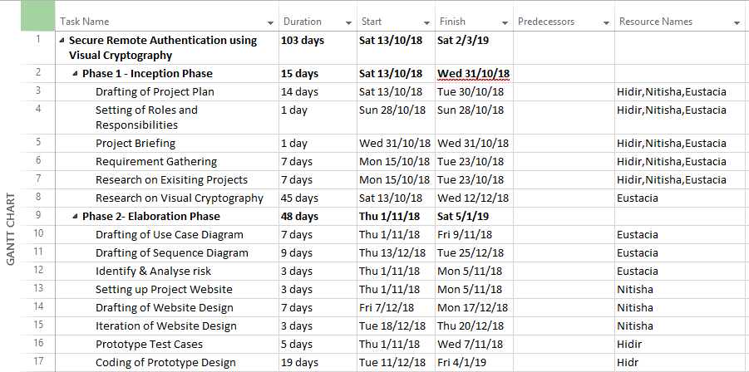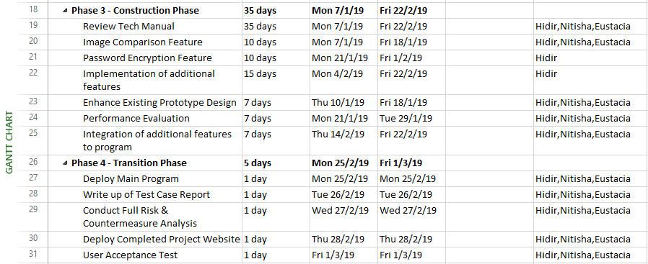

## Project Website

The following is our project website link:

<https://veramorgana.wixsite.com/vcauth/>

## Use Case Diagram

### Iteration 1

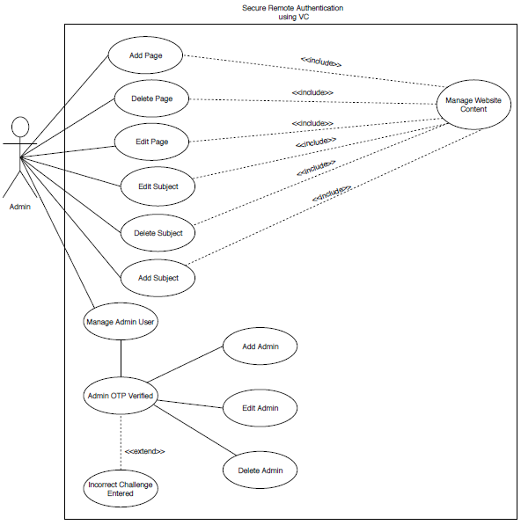

### Iteration 2

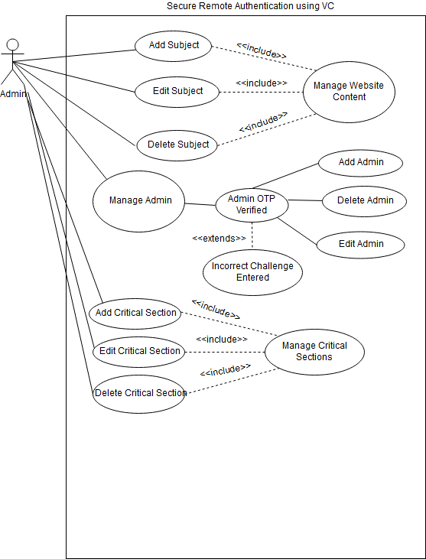

## Detailed Use Case

|  |  |
| --- | --- |
| **Use Case ID** | UC-0001 |
| **Use Case Name** | Add Subject |
| **Brief Description** | Admin add subject to the website content |
| **Actor(s)** | Admin |
| **Pre-condition(s)** | Admin has already logged in |
| **Post-condition(s)** | Subject will be added. |
| **Main Flow** | 1. Admin selects “Add New Subject”. 2. Admin enter Menu Name. 3. Admin selects position and visibility option. 4. Admin selects “Create Subject” button to submits the details of the subject. 5. Upon completion, the subject should be added under the menu. |
| **Alternate Flows** | ***2a. Menu Name is missing***   1. The program prompt for Menu Name. 2. Use case resumes at main flow step 3.   ***3a. Visibility option is missing***   1. The program prompt for visibility option. 2. Use case resumes at main flow step 4. |

|  |  |
| --- | --- |
| **Use Case ID** | UC-0002 |
| **Use Case Name** | Delete Subject |
| **Brief Description** | Delete on an existing subject from the website content |
| **Actor(s)** | Admin |
| **Pre-condition(s)** | Admin has already logged in |
| **Post-condition(s)** | Subject will be deleted. |
| **Main Flow** | 1. Admin selects on one of the existing subjects from the menu. 2. Admin selects on “Edit Subject”. 3. Admin selects on “Delete Subject”. 4. System prompts Admin to confirm user’s selection 5. Admin selects “OK”. 6. Upon completion, the subject will be deleted. |
| **Alternate Flows** | ***5a. When admin deletes a subject with existing pages under it***   1. System will display an error message. 2. Admin must delete any existing pages linked to the subject first. |

|  |  |
| --- | --- |
| **Use Case ID** | UC-0003 |
| **Use Case Name** | Edit Subject |
| **Brief Description** | Admin edit on an existing subject |
| **Actor(s)** | Admin |
| **Pre-condition(s)** | Admin has already logged in |
| **Post-condition(s)** | Subject will be edited. |
| **Main Flow** | 1. Admin selects on one of the existing subjects from the menu. 2. Admin selects on “Edit Subject”. 3. Admin edit the Menu Name, position or visibility option. 4. Admin selects “Edit Subject” button to submits the edited details of the subject. 5. Upon completion, the subject of the menu name, position or visibility option should be edited according to the admin preference. |

|  |  |
| --- | --- |
| **Use Case ID** | UC-0004 |
| **Use Case Name** | Admin 2FA Verified |
| **Brief Description** | User to be 2FA verified before accessing critical section of system. |
| **Actor(s)** | User (Admin) |
| **Pre-condition(s)** | User accesses a page identified as a critical section by the system. |
| **Post-condition(s)** | User granted access to critical section until logged out. |
| **Main Flow** | 1. User attempts to access page 2. System check if page is a critical section. 3. System generates 6-long random string as a challenge string and converts it into image displaying string. 4. System hashes the challenge string and links it to the user. 5. System calls VC Script and divides image into 2 shares: User & Server Share 6. System emails User Share to email linked to User. 7. System keeps Server share. 8. System removes base image and user share from server. 9. System prompts user to upload share sent to their email. 10. User uploads the share they received. 11. System calls VC Script and combines user-uploaded image to server share. 12. System displays combined image which will display the same challenge string generated in Step 3. 13. System prompts user to enter challenge displayed. 14. User enters challenge as seen in combined image. 15. System hashes user input and checks if same as hash linked to user in Step 4. 16. User granted temporary access to critical section of system until logged off. |
| **Alternate Flows** | ***2a. System detects page as Non-Critical***   1. User will have direct access to the page and no 2FA is required.   ***10a. User Uploads Incorrect Share File***   1. Displayed combined image in Step 12 will display gibberish. User will thus be unable to proceed as they are not able to enter the correct challenge. |

|  |  |
| --- | --- |
| **Use Case ID** | UC-0005 |
| **Use Case Name** | Add Critical Section |
| **Brief Description** | Admin can add pages that require additional security as critical sections. |
| **Actor(s)** | Admin |
| **Pre-condition(s)** | Admin has already logged in |
| **Post-condition(s)** | A page will be added as a critical section |
| **Main Flow** | 1. Admin selects “Add New Critical Sections”. 2. Admin enter Menu Name. 3. Admin selects security level and decide if they want to use Fast Auth 4. Admin selects “Create Critical Section” button to submits the details of the critical section 5. Upon completion, the page should be added under the menu. |
| **Alternate Flows** | ***2a. Any Field is missing***   1. The program prompt for missing field |

|  |  |
| --- | --- |
| **Use Case ID** | UC-0006 |
| **Use Case Name** | Edit Critical Section |
| **Brief Description** | Admin can edit existing critical sections and their options |
| **Actor(s)** | Admin |
| **Pre-condition(s)** | Admin has already logged in |
| **Post-condition(s)** | A page listed as critical section will be updated |
| **Main Flow** | 1. Admin selects “Edit Critical Sections” from the list. 2. Admin updates Menu Name. 3. Admin update security level and decide if they want to use Fast Auth 4. Admin selects “Update” button to submits the changes of the critical section 5. Upon completion, the page should be added under the menu. |
| **Alternate Flows** | ***2a. Any Field is missing***   1. The program prompt for missing field |

|  |  |
| --- | --- |
| **Use Case ID** | UC-0007 |
| **Use Case Name** | Delete Critical Section |
| **Brief Description** | Admin can delete existing critical sections |
| **Actor(s)** | Admin |
| **Pre-condition(s)** | Admin has already logged in |
| **Post-condition(s)** | A page listed as critical section will be deleted. |
| **Main Flow** | 1. Admin selects “Delete Critical Sections” from the list. 2. Admin confirms deletion. |
| **Alternate Flows** | ***2a. Any Field is missing***   1. The program prompt for missing field |

|  |  |
| --- | --- |
| **Use Case ID** | UC-0008 |
| **Use Case Name** | Admin 2FA Verified **Level 1** |
| **Brief Description** | User to be 2FA verified before accessing critical section of system by uploading 1 share image sent to his main email. |
| **Actor(s)** | Admin |
| **Pre-condition(s)** | Admin accesses a page identified as a critical section level 1 by the system. |
| **Post-condition(s)** | Admin granted access to critical section until logged out. |
| **Main Flow** | 1. User attempts to access page 2. System check if page is a critical section. 3. System generates 6-long random string as a challenge string and converts it into image displaying string. 4. System hashes the challenge string and links it to the user in Database 5. System calls VC Script and divides image into 2 shares: User & Server Share 6. System emails User Share to email linked to User. 7. System keeps Server share. 8. System removes base image and user share from server. 9. System prompts user to upload share sent to their email. 10. User uploads the share they received. 11. System calls VC Script and combines user-uploaded image to server share. 12. System displays combined image which will display the same challenge string generated in Step 3. 13. System prompts user to enter challenge displayed. 14. User enters challenge as seen in combined image. 15. System hashes user input and checks if same as hash linked to user in Step 4. 16. User granted temporary access to critical section of system until logged off. |
| **Alternate Flows** | ***2a. System detects page as Non-Critical***   1. User will have direct access to the page and no 2FA is required.   ***12a. Fast Auth Enabled***   1. System will use Image Recognition Module to allow user to skip the step of having to enter Challenge manually.   ***10a. User Uploads Incorrect Share File***   1. Displayed combined image in Step 12 will display gibberish. User will thus be unable to proceed as they are not able to enter the correct challenge. |

|  |  |
| --- | --- |
| **Use Case ID** | UC-0009 |
| **Use Case Name** | Admin 2FA Verified **Level 2** |
| **Brief Description** | User to be 2FA verified before accessing critical section of system by uploading 2 share images, 1st to his main email, 2nd to his secondary email. |
| **Actor(s)** | Admin |
| **Pre-condition(s)** | Admin accesses a page identified as a critical section level 2 by the system. |
| **Post-condition(s)** | Admin granted access to critical section until logged out. |
| **Main Flow** | 1. User attempts to access page 2. System check if page is a critical section. 3. System generates 6-long random string as a challenge string and converts it into image displaying string. 4. System hashes the challenge string and links it to the user in Database 5. System calls VC Script and divides image into 3 shares: User Share 1, User Share 2 & Server Share 6. System emails User Share 1 to email1 linked to User. 7. System emails User Share 2 to email2 linked to User. 8. System keeps Server share. 9. System removes base image and user share from server. 10. System prompts user to upload share sent to their email. 11. User uploads both the share they received. 12. System calls VC Script and combines both user-uploaded images to server share. 13. System displays combined image which will display the same challenge string generated in Step 3. 14. System prompts user to enter challenge displayed. 15. User enters challenge as seen in combined image. 16. System hashes user input and checks if same as hash linked to user in Step 4. 17. User granted temporary access to critical section of system until logged off. |
| **Alternate Flows** | ***2a. System detects page as Non-Critical***   1. User will have direct access to the page and no 2FA is required.   ***12a. Fast Auth Enabled***   1. System will use Image Recognition Module to allow user to skip the step of having to enter Challenge manually.   ***10a. User Uploads Incorrect Share File***   1. Displayed combined image in Step 12 will display gibberish. User will thus be unable to proceed as they are not able to enter the correct challenge. |

|  |  |
| --- | --- |
| **Use Case ID** | UC-0010 |
| **Use Case Name** | Admin 2FA Verified **Level 3** |
| **Brief Description** | User to be 2FA verified before accessing critical section of system by uploading 2 share images, 1st to his main email, 2nd to page master |
| **Actor(s)** | Admin |
| **Pre-condition(s)** | Admin accesses a page identified as a critical section level 2 by the system. |
| **Post-condition(s)** | Admin granted access to critical section until logged out. |
| **Main Flow** | 1. User attempts to access page 2. System check if page is a critical section. 3. System generates 6-long random string as a challenge string and converts it into image displaying string. 4. System hashes the challenge string and links it to the user in Database 5. System calls VC Script and divides image into 3 shares: User Share 1, User Share 2 & Server Share 6. System emails User Share 1 to email1 linked to User. 7. System emails User Share 2 to Page Master linked to the Critical Section. 8. System keeps Server share. 9. System removes base image and user share from server. 10. System prompts user to upload share sent to their email. 11. User goes to his email to get Share1. 12. User await page master to forward him the second share as sign of approval to access the page. 13. User uploads both the share they received. 14. System calls VC Script and combines both user-uploaded images to server share. 15. System displays combined image which will display the same challenge string generated in Step 3. 16. System prompts user to enter challenge displayed. 17. User enters challenge as seen in combined image. 18. System hashes user input and checks if same as hash linked to user in Step 4. 19. User granted temporary access to critical section of system until logged off. |
| **Alternate Flows** | ***2a. System detects page as Non-Critical***   1. User will have direct access to the page and no 2FA is required.   ***12a. Fast Auth Enabled***   1. System will use Image Recognition Module to allow user to skip the step of having to enter Challenge manually.   ***10a. User Uploads Incorrect Share File***   1. Displayed combined image in Step 12 will display gibberish. User will thus be unable to proceed as they are not able to enter the correct challenge. |

## Workflow Diagram

### Add Admin

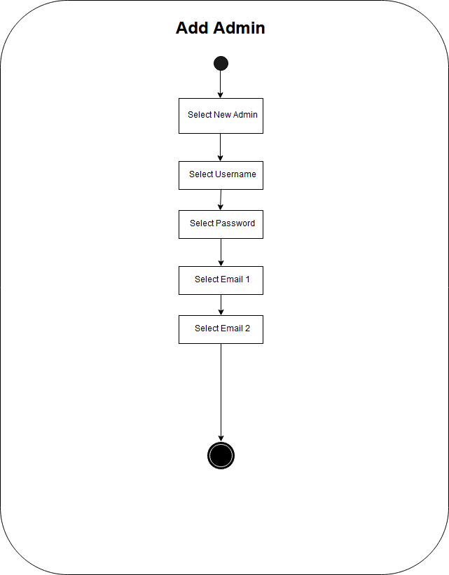

### Delete Admin

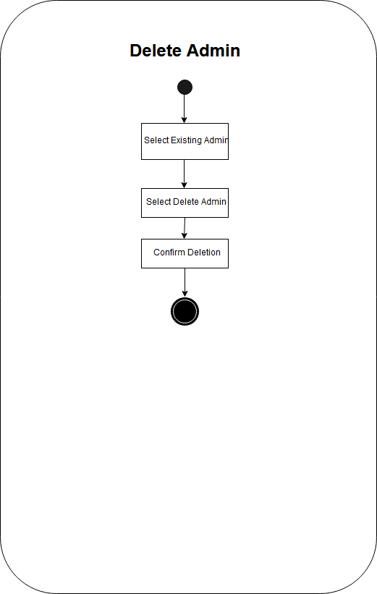

### Edit Admin

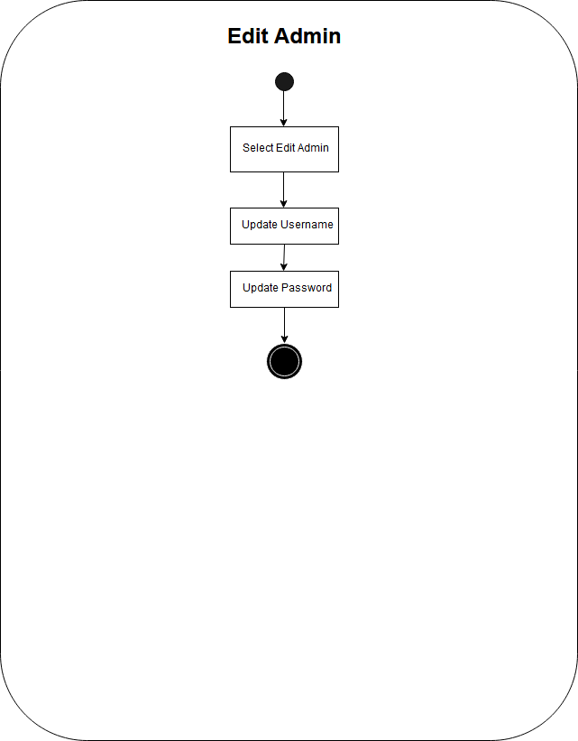

### Create Subject

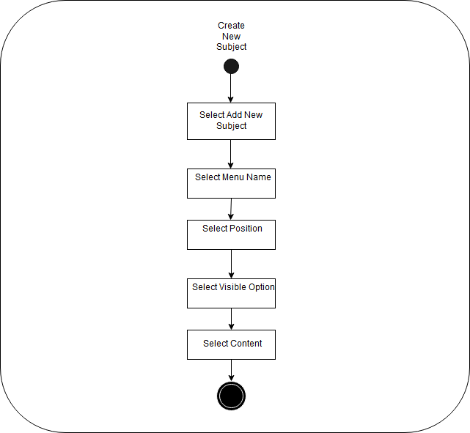

### Delete Subject

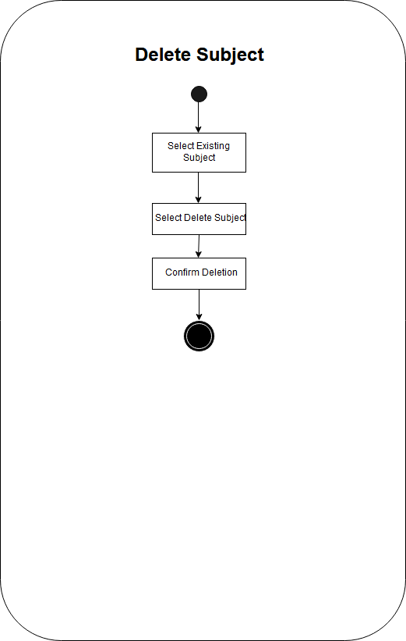

### Edit Subject

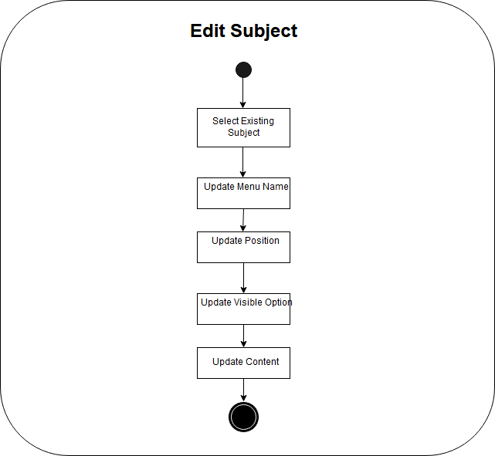

### Create New Critical Section

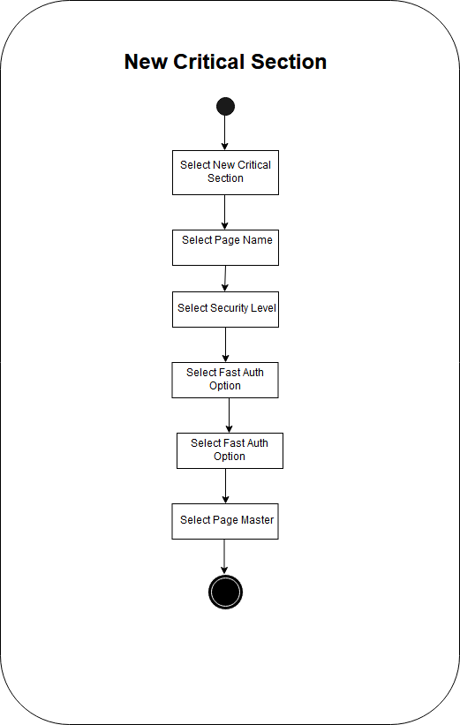

### Delete Critical Section

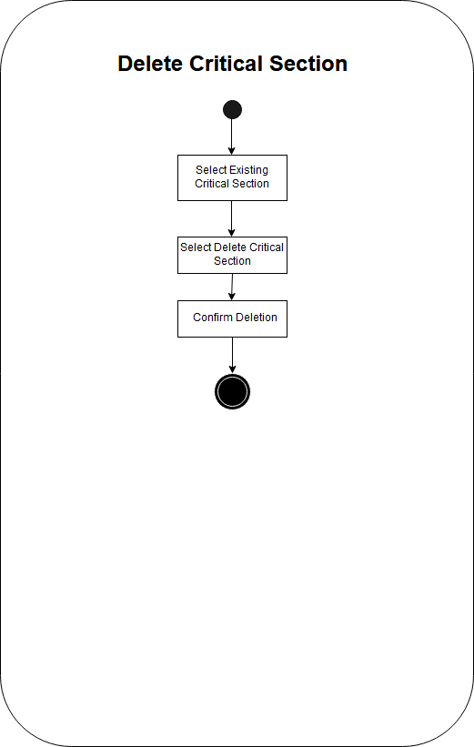

### Edit Critical Section

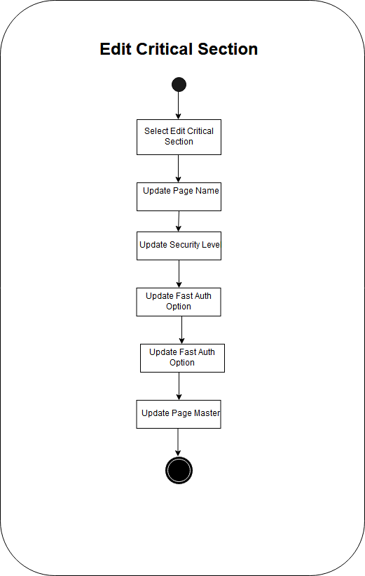

## Sequence Diagram

### Iteration 1

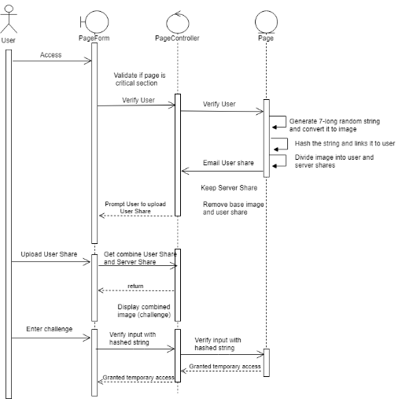

## User Interface

### Front End

#### Iteration 1

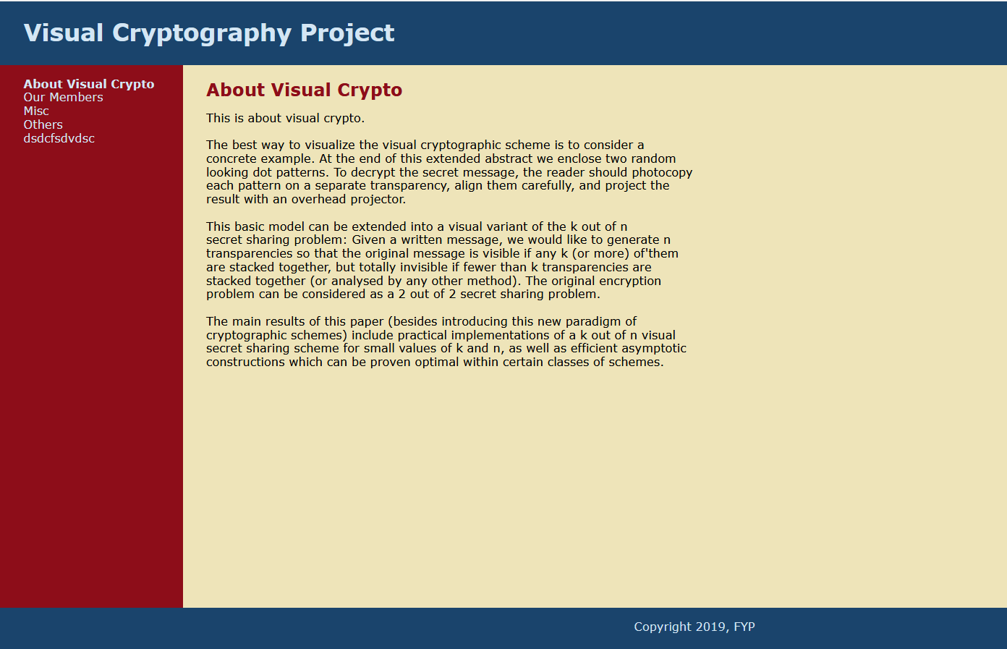

#### Iteration 2

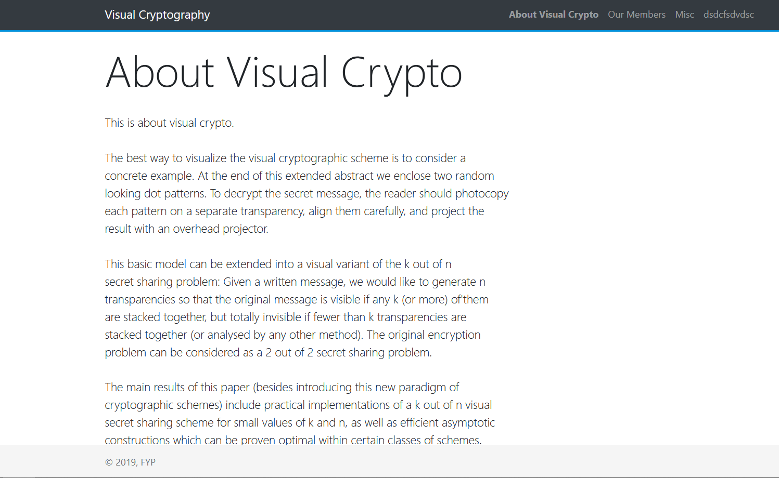

### Admin Menu

#### Iteration 1

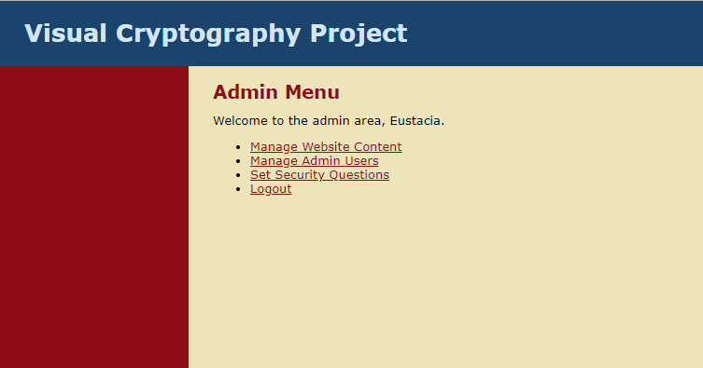

#### Iteration 2

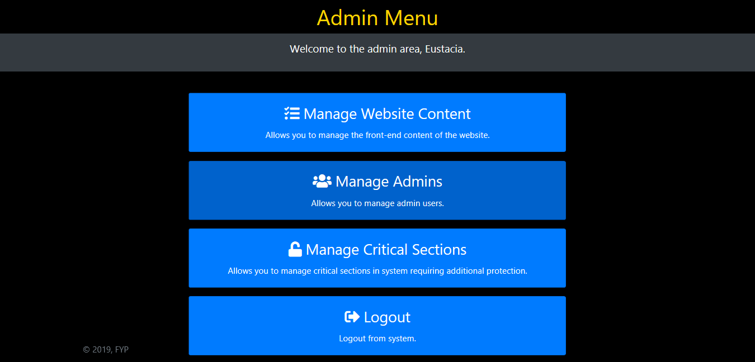

### Manage Website Content

#### Iteration 1

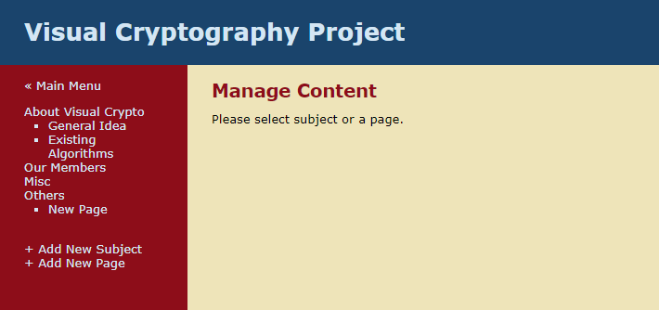

#### Iteration 2

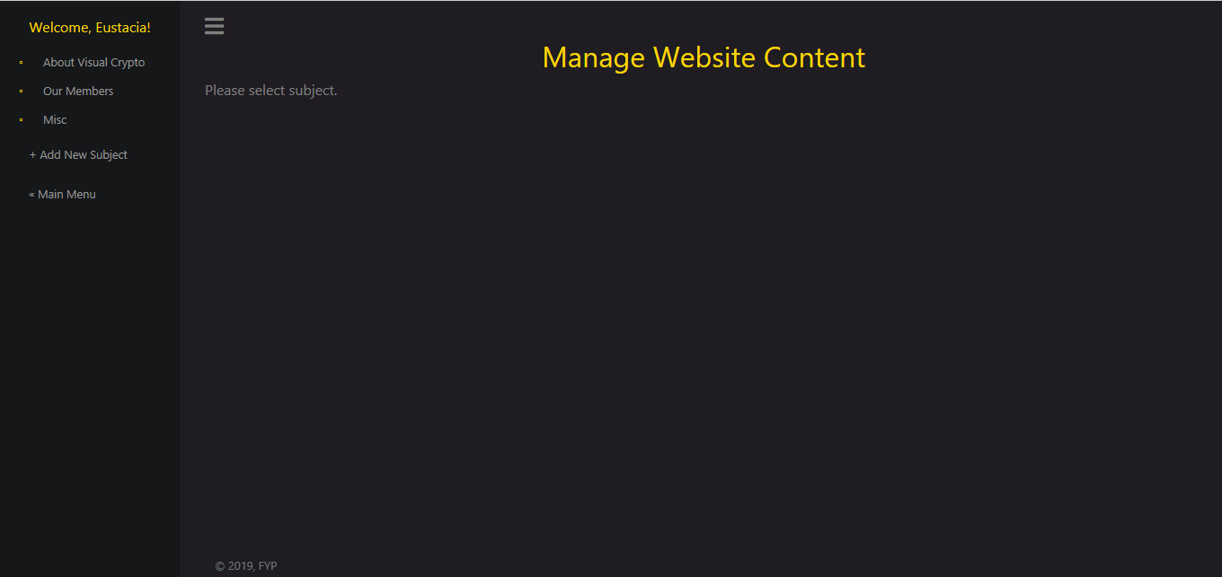

### Manage Subject

#### Iteration 2

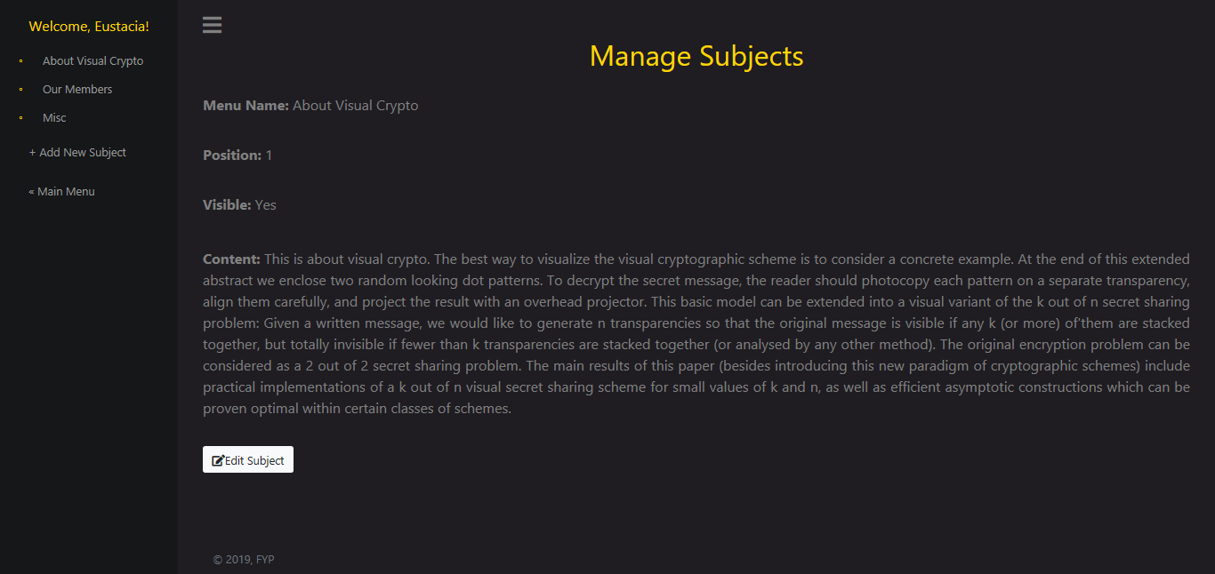

### Edit Subject

#### Iteration 1

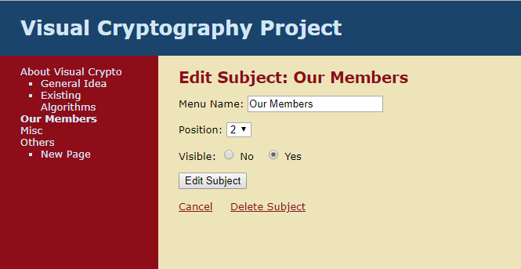

#### Iteration 2

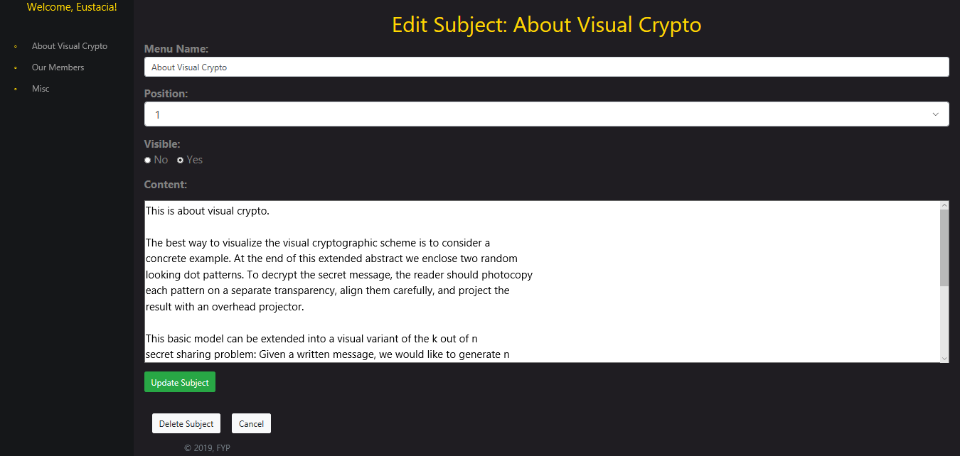

### Create Subject

#### Iteration 1

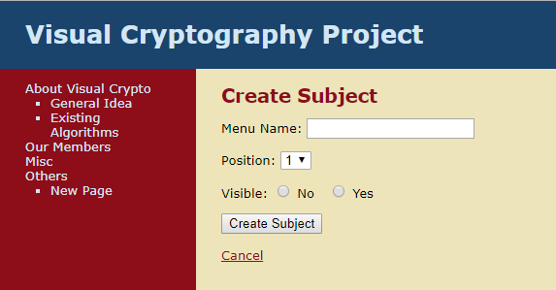

#### Iteration 2

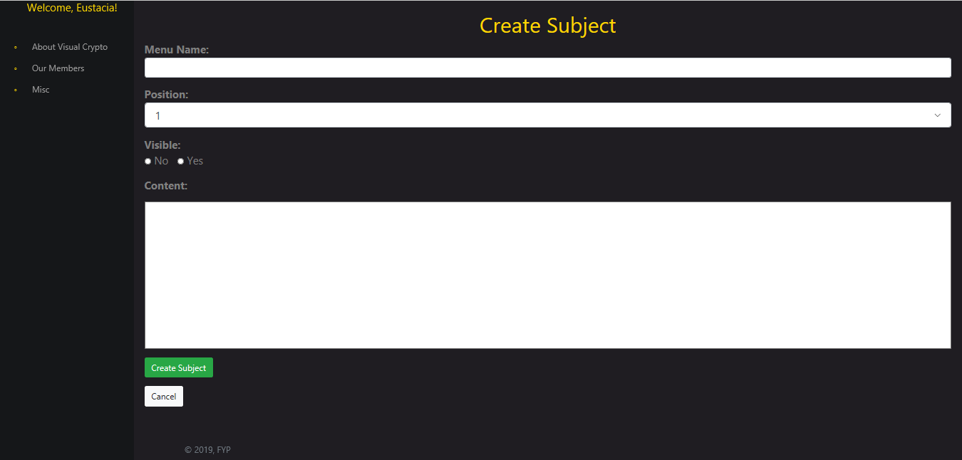

### Subject Created

#### Iteration 1

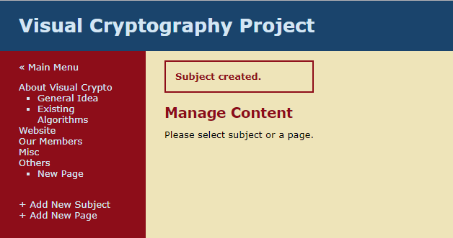

#### Iteration 2

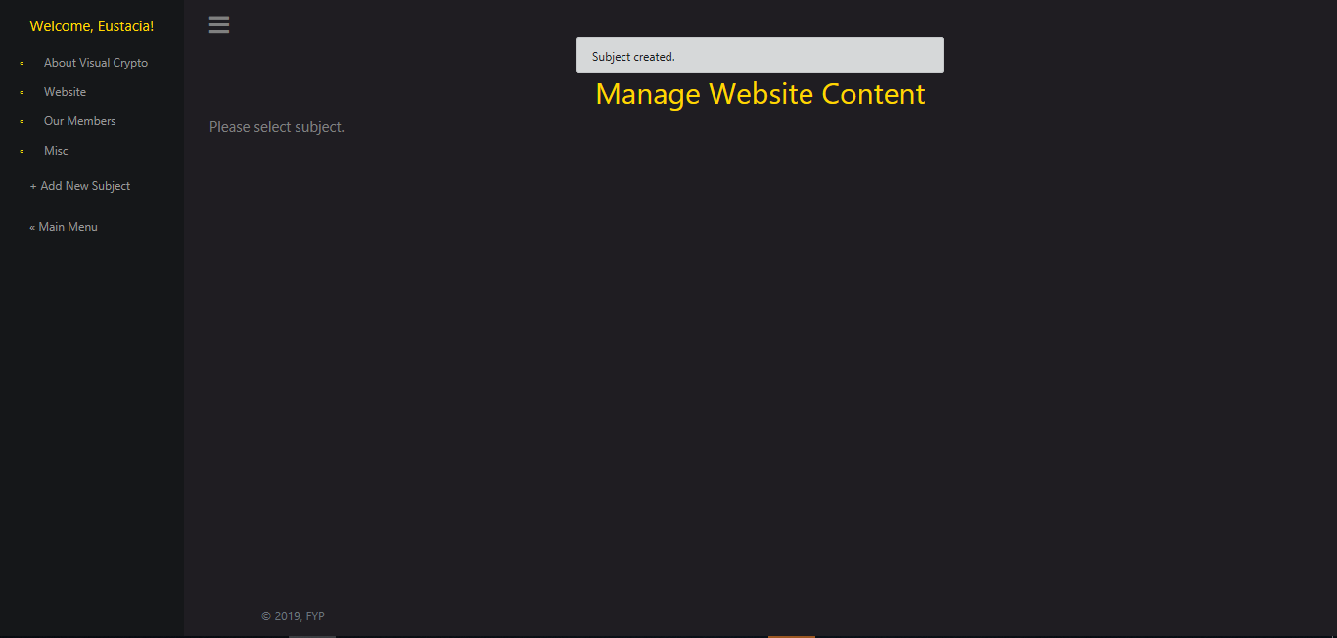

### Subject Deleted

#### Iteration 2

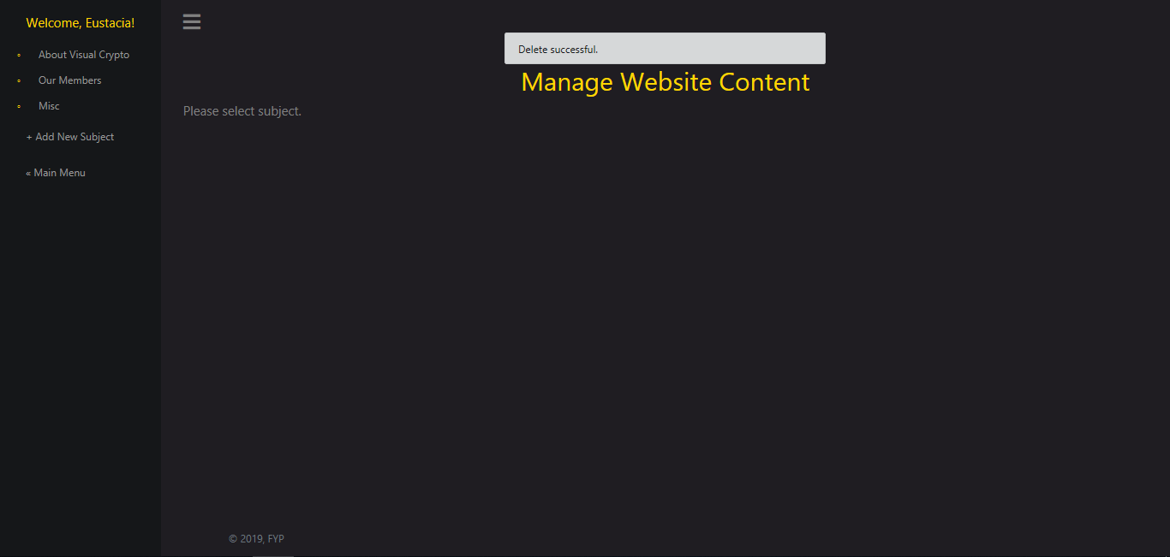

### Manage Admins

#### Iteration 2

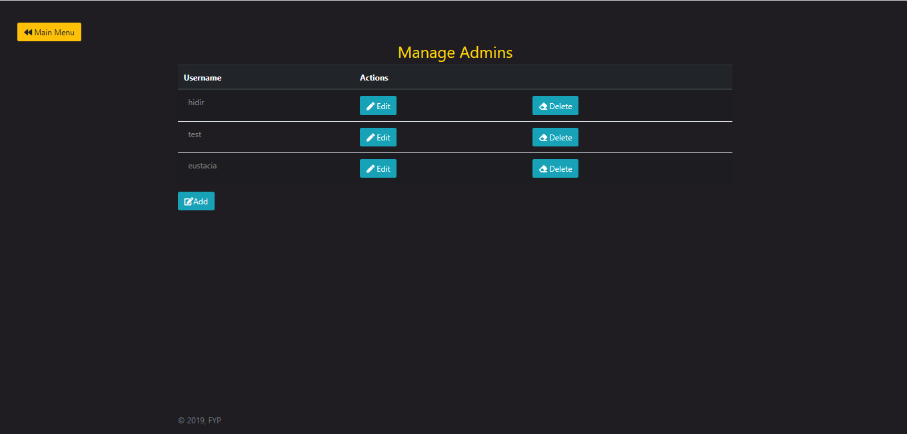

### Create New Admins

#### Iteration 2

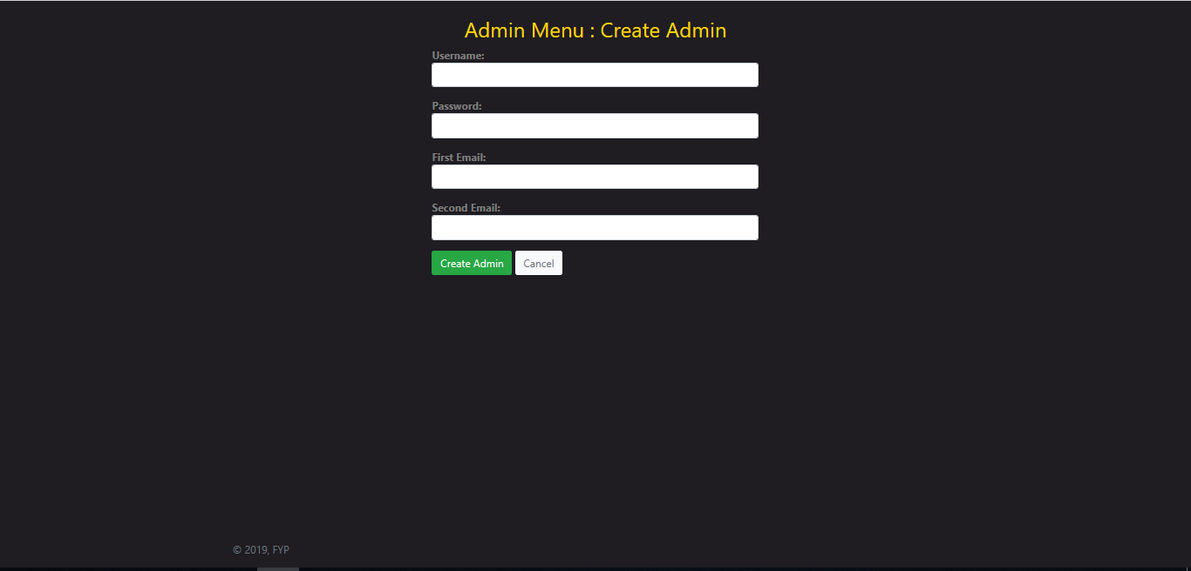

### Update Admin’s Username & Password

#### Iteration 2

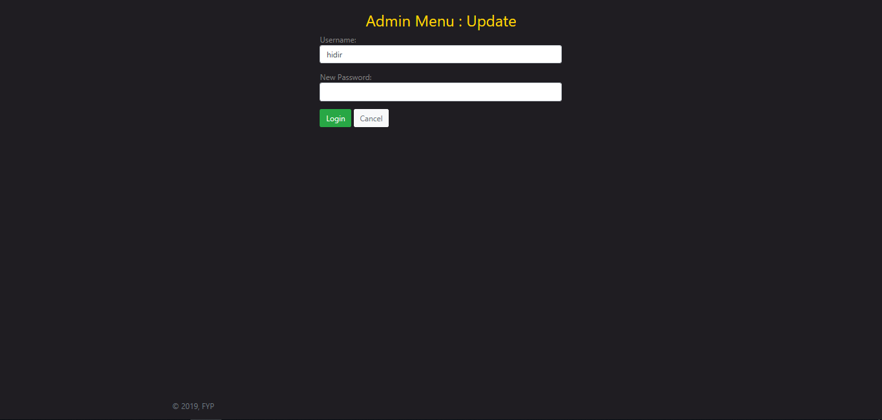

### Delete Admin

#### Iteration 2

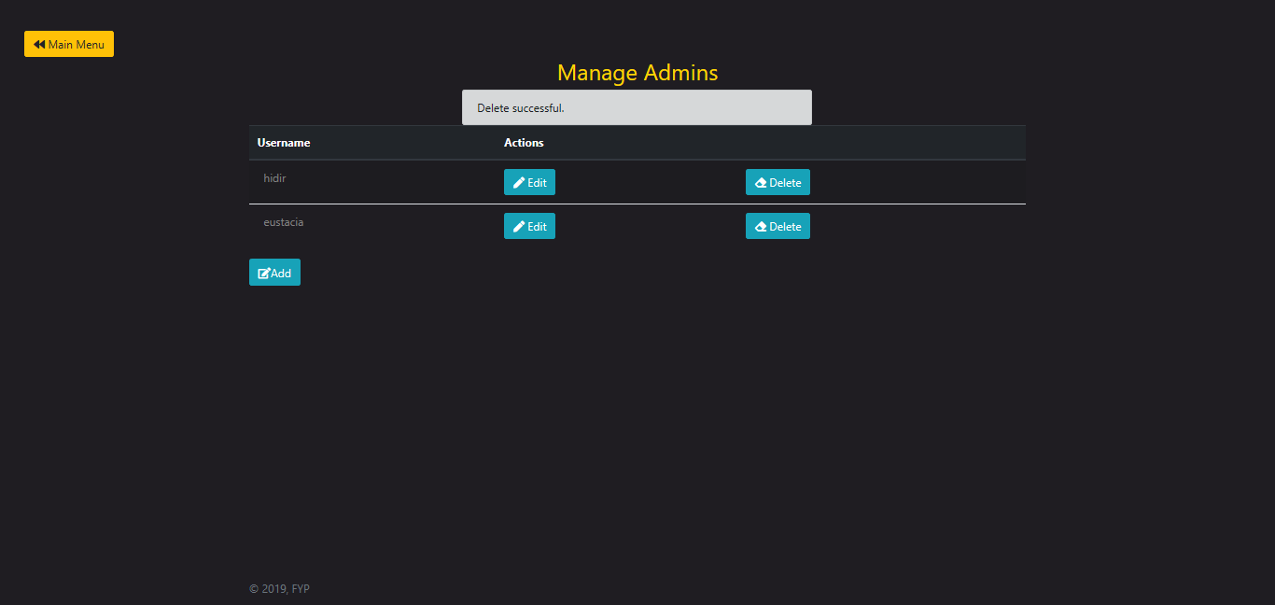

### Verification

#### Stage 1

##### Iteration 1

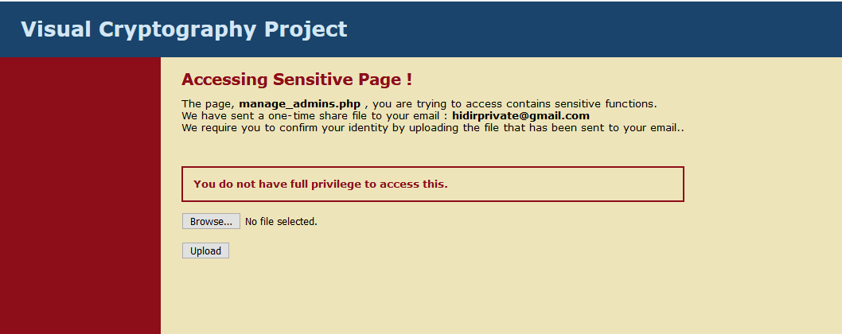

##### Iteration 2

###### **Level 1**

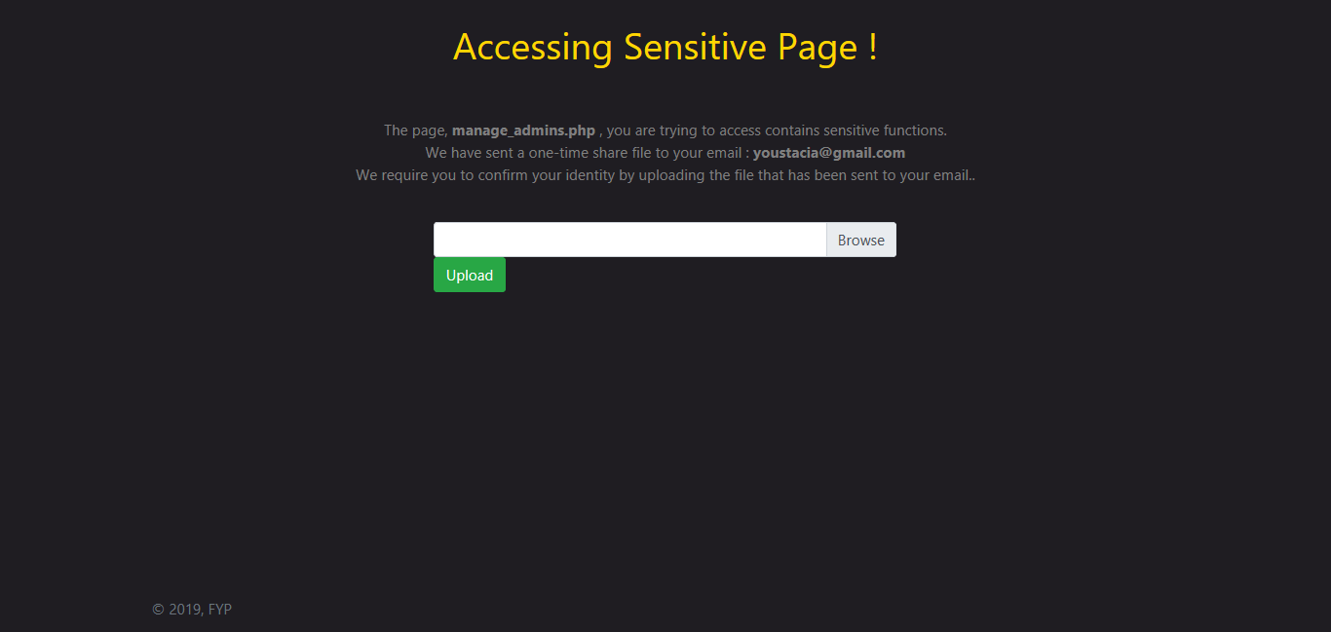

###### **Level 2**

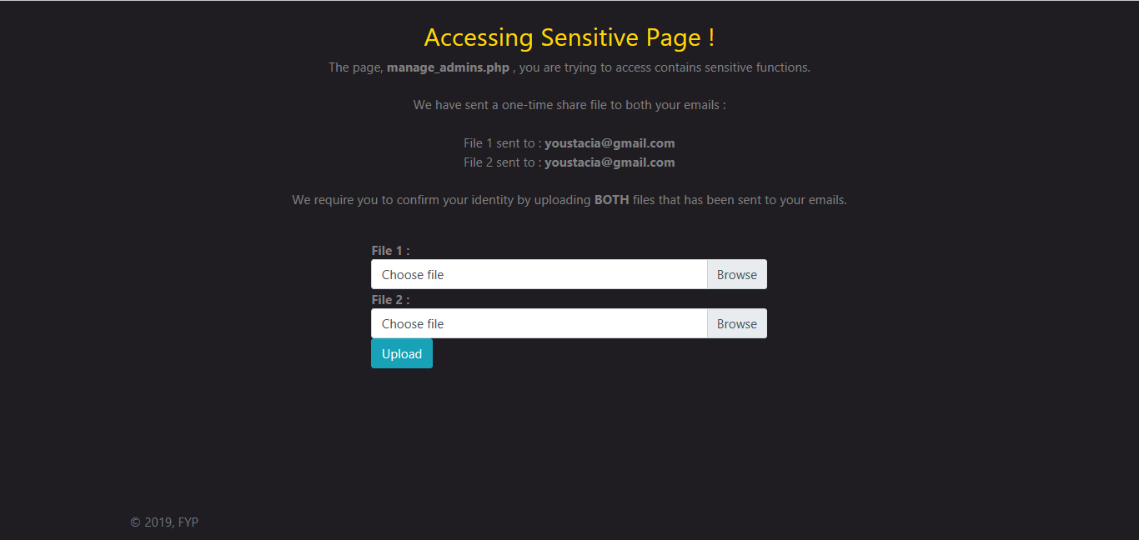

###### **Level 3**

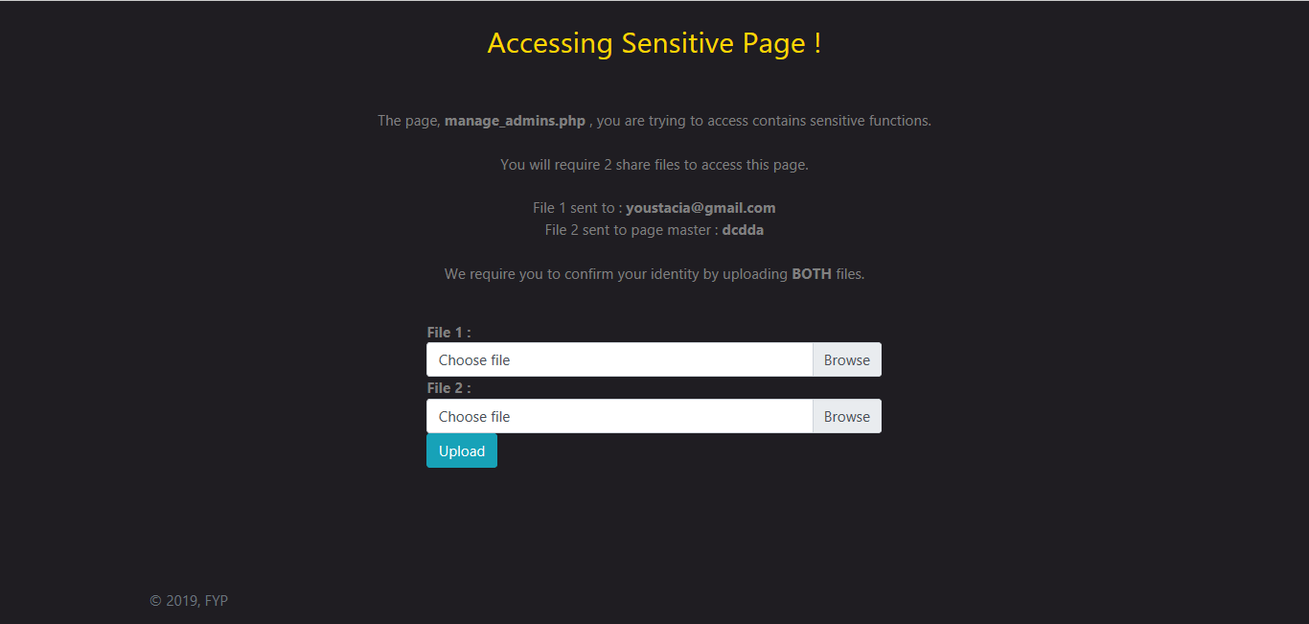

###### Verification Email Sent

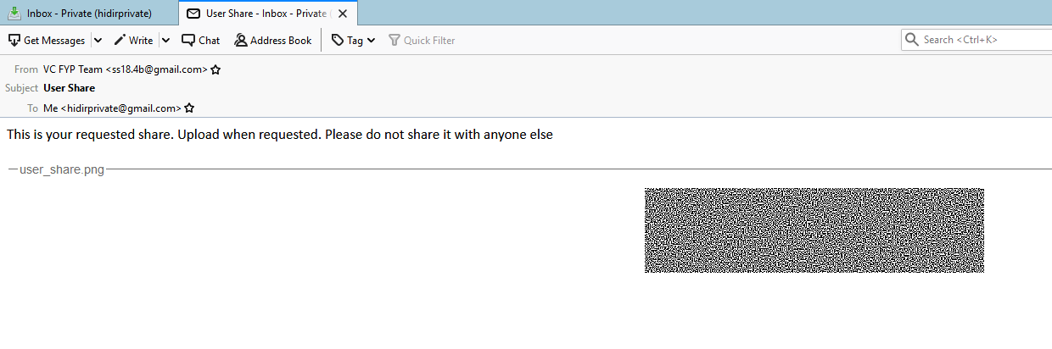

#### Stage 2

##### Iteration 1

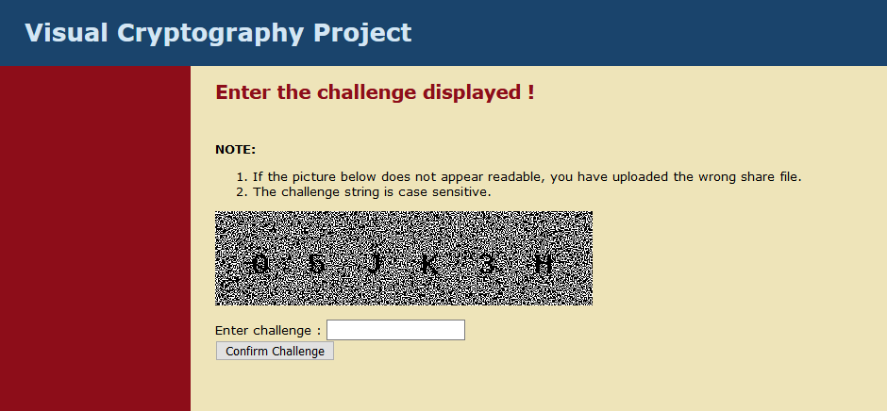

##### Iteration 2

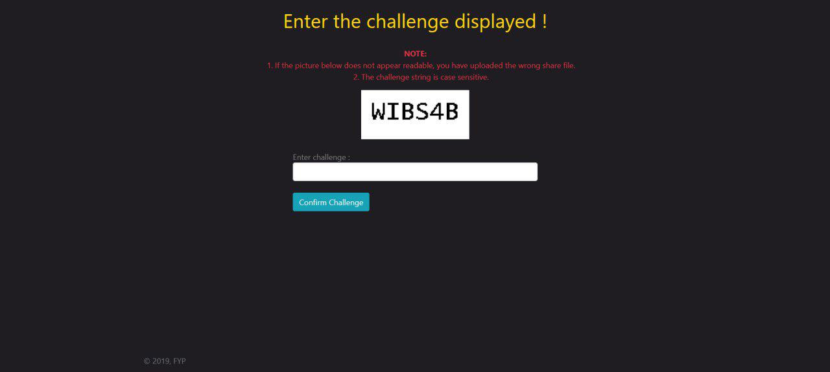

### Manage Critical Section

#### Iteration 2

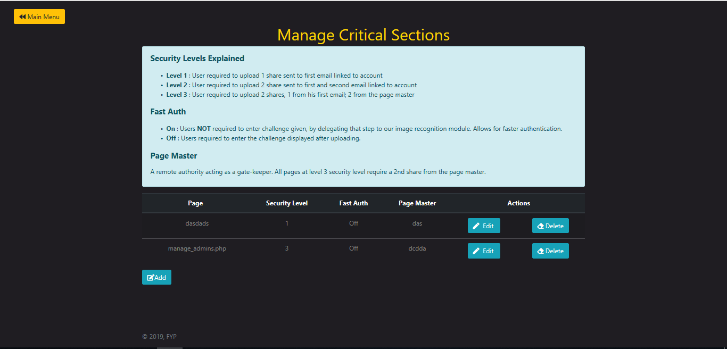

### Add New Critical Section

#### Iteration 2

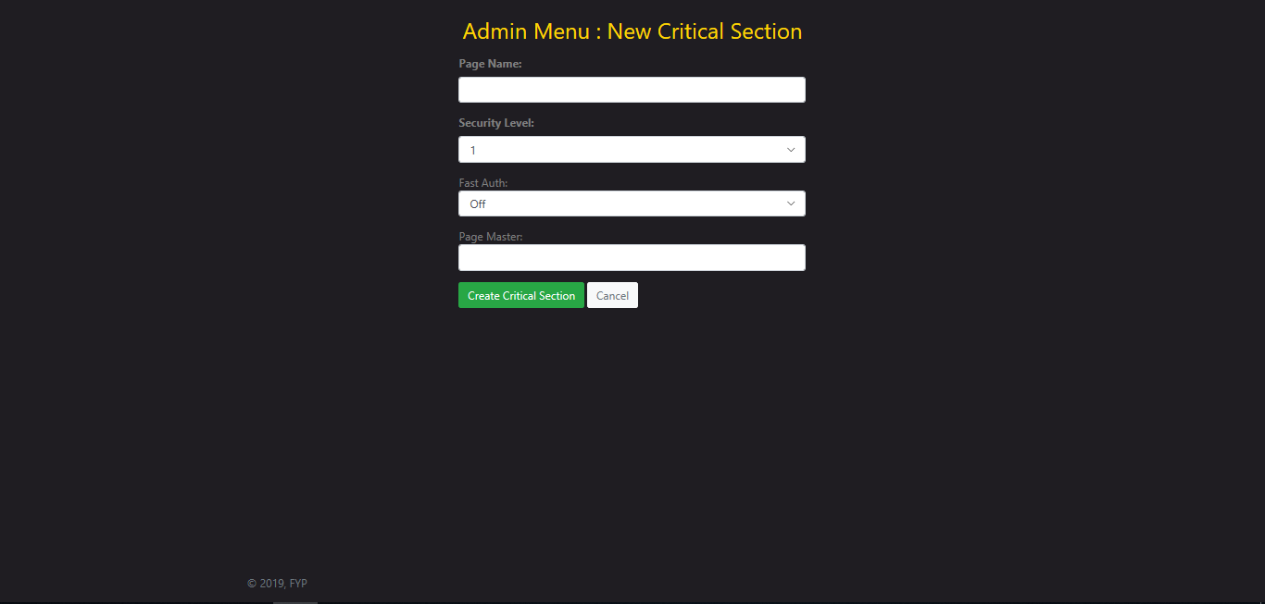

### Update New Critical Section

#### Iteration 2

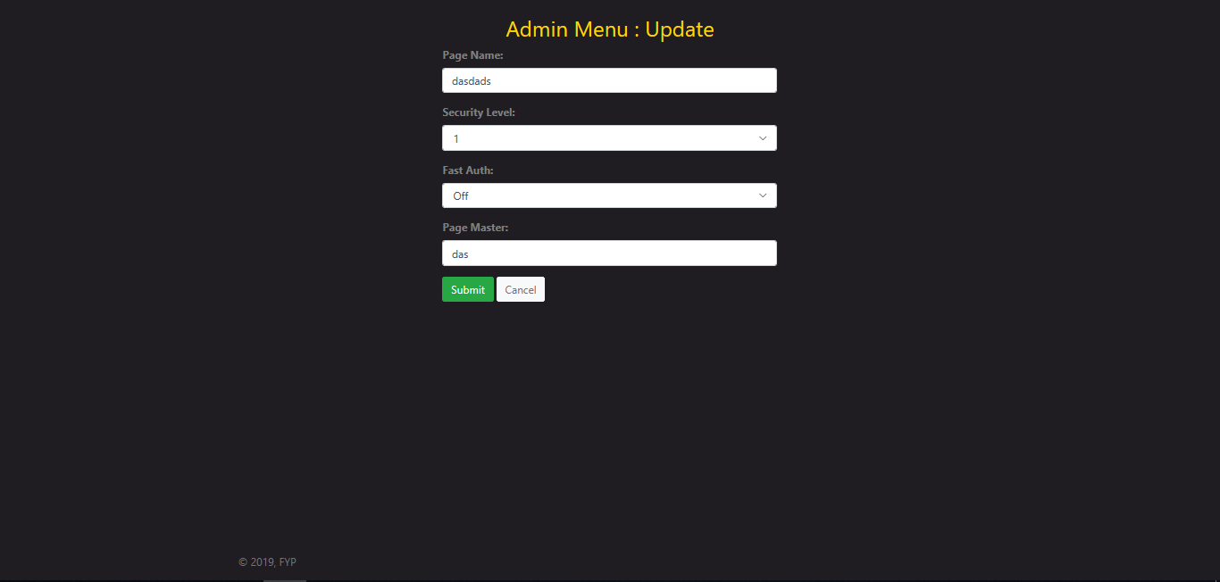

### Delete Critical Section

#### Iteration 2

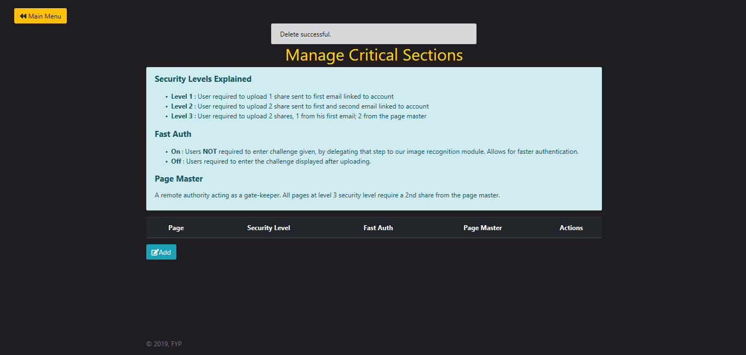

## Development Methodology

Rational Unified Process (RUP) is an iterative software development process framework. It is adaptive and not based on a single concrete perspective. RUP is intended to be tailored by software project teams whereby they will select elements of the process that are appropriate to their needs.   
  
There are three disciplines that encompass modelling activities for a single project in the RUP - Business Modelling, Requirements, and Analysis & Design

The development process is divided into four distinct phases

1. Inception

Project idea is stated. The development team determines if the project is worth pursuing and the resources needed.

1. Elaboration

Further evaluation of the project's architecture and required resources. Possible applications of the software and costs associated with the development are taken into consideration by developers.

1. Construction

The project is developed and completed. The software is designed, written, and tested.

1. Transition

The software is released to the public. Final adjustments or updates are made based on feedback from end users.

## Test Cases

We have done some testing on common features. Due to vigorous testing during implementation, we had 18 out of 19 successful test cases, with only 1 test cases. We have successfully rectified the test case that failed.

|  |  |  |  |  |
| --- | --- | --- | --- | --- |
| **Test Case ID:** 1 | | | | |
| **Description:** Admin Logging In with Correct Password | | | | |
| **Precondition:** Admin not logged in | | | | |
| **Test Steps** | **Test Data** | **Expected Results** | **Actual Result** | **Test Result (Pass/Fail)** |
| User enters username and password.  Clicks “Submit” | Page name “login.php”  Username: test  Password: test | User should be able to proceed to admin.php. | User proceeds to admin.php | Pass |
| **Post-conditions:** | | | | |

|  |  |  |  |  |
| --- | --- | --- | --- | --- |
| **Test Case ID:** 2 | | | | |
| **Description:** Admin Logging In with Wrong Password | | | | |
| **Precondition:** Admin not logged in | | | | |
| **Test Steps** | **Test Data** | **Expected Results** | **Actual Result** | **Test Result (Pass/Fail)** |
| User enters username and password.  Clicks “Submit” | Page name “login.php”  Username: test  Password: test | User should be given message of incorrect password and login failed. | User given message of incorrect password and failed. | Pass |
| **Post-conditions:** User will be asked to re-enter login details (_____ attempts) | | | | |

|  |  |  |  |  |
| --- | --- | --- | --- | --- |
| **Test Case ID:** 3 | | | | |
| **Description:** Admin Logging Out | | | | |
| **Precondition:** Admin currently logged in | | | | |
| **Test Steps** | **Test Data** | **Expected Results** | **Actual Result** | **Test Result (Pass/Fail)** |
| Click “Log Out” | Page name “logout.php” | Admin should get logged out and no longer have access to admin.php | Admin logged out and no longer have access to admin.php | Pass |
| **Post-conditions:** Admin no longer has access to admin pages. | | | | |

|  |  |  |  |  |
| --- | --- | --- | --- | --- |
| **Test Case ID:** 4.1 | | | | |
| **Description:** Adding New Subject | | | | |
| **Precondition:** Admin already logged in | | | | |
| **Test Steps** | **Test Data** | **Expected Results** | **Actual Result** | **Test Result (Pass/Fail)** |
| User enters menu name, position, visibility and content  Clicks “Create Subject” | Page name “Test Page”  Position 5  Visibility On  Content “Hello 1 2 3” | New subject should be created | Subject failed. Returning exception error | Fail |
| **Post-conditions:** New subject now available to all users | | | | |

|  |  |  |  |  |
| --- | --- | --- | --- | --- |
| **Test Case ID:** 4.2 | | | | |
| **Description:** Adding New Subject | | | | |
| **Precondition:** Admin already logged in | | | | |
| **Test Steps** | **Test Data** | **Expected Results** | **Actual Result** | **Test Result (Pass/Fail)** |
| User enters menu name, position, visibility and content  Clicks “Create Subject” | Page name “Test Page”  Position 5  Visibility On  Content “Hello 1 2 3” | New subject should be created | Subject created successfully. Previous failed because forgot to include validation_functions.php at the top of new_subject.php | Pass |
| **Post-conditions:** New subject now available to all users | | | | |

|  |  |  |  |  |
| --- | --- | --- | --- | --- |
| **Test Case ID:** 5 | | | | |
| **Description:** Editing Existing Subject | | | | |
| **Precondition:** Admin already logged in | | | | |
| **Test Steps** | **Test Data** | **Expected Results** | **Actual Result** | **Test Result (Pass/Fail)** |
| User change menu name from “Test Page” to “Tests Page 2”, position from 5 to 4, visibility to off and content from “Hello 1 2 3” to “Hello 1 2 3 4”.  Clicks “Edit Subject” | Page name “Test Page”  Position 4  Visibility Off  Content “Hello 1 2 3 4” | All values of “Test Page” should change accordingly to Test Data Values | All values of “Test Page” successfully changed accordingly to Test Data Values | Pass |
| **Post-conditions:** Subject has new values. | | | | |

|  |  |  |  |  |
| --- | --- | --- | --- | --- |
| **Test Case ID:** 6 | | | | |
| **Description:** Deleting Existing Subject | | | | |
| **Precondition:** Admin already logged in | | | | |
| **Test Steps** | **Test Data** | **Expected Results** | **Actual Result** | **Test Result (Pass/Fail)** |
| User picks a subject that he wants to delete.  Click confirmation “Yes | Page name “Test Page” | Test page should be deleted from database and list of subjects. | Test page deleted from database and list of subjects | Pass |
| **Post-conditions:** Subject no longer shown. | | | | |

|  |  |  |  |  |  |  |  |
| --- | --- | --- | --- | --- | --- | --- | --- |
| **Test Case ID:** 7 | | | | | | | |
| **Description:** Create admin | | | | | | | |
| **Precondition:** Admin already logged in; Admin must have necessary privileges | | | | | | | |
| **Test Steps** | **Test Data** | | **Expected Results** | | **Actual Result** | | **Test Result (Pass/Fail)** |
| Admin enters username, password, first email, second email  Clicks “Create Admin” | Page name “new_admin.php”  Username “test”  Password “test123”  Email [thistest@gmail.com](mailto:thistest@gmail.com)  Second email: [thistest2@gmail.com](mailto:thistest2@gmail.com) | | New admin should be created and stored in the database | | New admin created successfully, and admin details stored in the database | | Pass |
| **Post-conditions:** User will need to ask Admin if modification of details is required | | | | | | | |
| **Test Case ID:** 8 | | | | | | | |
| **Description:** Edit Admin | | | | | | | |
| **Precondition:** Admin already logged in; Admin has passed VC Auth | | | | | | | |
| **Test Steps** | **Test Data** | **Expected Results** | | **Actual Result** | | **Test Result (Pass/Fail)** | |
| Admin change value of username and password of existing user. | Username from “test” change to “test2”  Password from “test123” to “test1234” | Username should now be shown as test2 instead of test. | | Username shown as test2. | | Pass | |
| **Post-conditions: Re login as that user to see if can [ PASS]** | | | | | | | |

|  |  |  |  |  |
| --- | --- | --- | --- | --- |
| **Test Case ID:** 9 | | | | |
| **Description:** Delete Admin | | | | |
| **Precondition:** User currently logged in; must me an Admin | | | | |
| **Test Steps** | **Test Data** | **Expected Results** | **Actual Result** | **Test Result (Pass/Fail)** |
| Delete an existing user using the Delete button.  Click Yes for Confirmation | User test2 | Existing admin should be deleted | Admin is deleted successfully | Pass |
| **Post-conditions:** Former Admin no longer has any access to sensitive pages | | | | |

|  |  |  |  |  |
| --- | --- | --- | --- | --- |
| **Test Case ID:** 10 | | | | |
| **Description:** Admin Adds New Critical Section | | | | |
| **Precondition:** Admin already logged in | | | | |
| **Test Steps** | **Test Data** | **Expected Results** | **Actual Result** | **Test Result (Pass/Fail)** |
| User enters name of page to secure, level of security and whether to enable fast auth.  Clicks “Submit” | Page name “test.php”  Level of Security 1  Fast Auth Off | Page will be created with level 1 security and fast auth off | Page created with level 1 security a fast auth off. | Pass |
| **Post-conditions:** User will be redirected to manage critical section page. | | | | |

|  |  |  |  |  |
| --- | --- | --- | --- | --- |
| **Test Case ID:** 11 | | | | |
| **Description:** Edit Critical Section | | | | |
| **Precondition:** User already logged in; User must have necessary privileges | | | | |
| **Test Steps** | **Test Data** | **Expected Results** | **Actual Result** | **Test Result (Pass/Fail)** |
| Admin enters page name, security level  Clicks “Submit” | Page name “edit_critical_section.php” | Security level of pages should be modified, providing more security to pages with higher security levels | Security level of pages are modified correctly | Pass |
| **Post-conditions:** Nil | | | | |

|  |  |  |  |  |
| --- | --- | --- | --- | --- |
| **Test Case ID:** 12 | | | | |
| **Description:** Delete Critical Section | | | | |
| **Precondition:** User currently logged in; must me an Admin | | | | |
| **Test Steps** | **Test Data** | **Expected Results** | **Actual Result** | **Test Result (Pass/Fail)** |
| Go to “Critical Sections”  Select the subject  Click “Delete” | Page name “manage_critical_section.php” | Existing page should be deleted | Page is deleted successfully | Pass |
| **Post-conditions:** Deleted subject is no longer accessible (non-existent) | | | | |

|  |  |  |  |  |
| --- | --- | --- | --- | --- |
| **Test Case ID:** 13 | | | | |
| **Description:** Accessing Page with Security Level 1 and uploading correct file. | | | | |
| **Precondition:** Currently logged in; Page must be added as critical section | | | | |
| **Test Steps** | **Test Data** | **Expected Results** | **Actual Result** | **Test Result (Pass/Fail)** |
| Access a page that is listed as critical section with level1 security.  Upload correct file sent to email  Enter the correct captcha image | Page with level1 security.  File “user_share.png” received in email. | Access will be granted to page | Access granted to page. | Pass |
| **Post-conditions:** If logged out, need to re-authenticate | | | | |

|  |  |  |  |  |
| --- | --- | --- | --- | --- |
| **Test Case ID:** 14 | | | | |
| **Description:** Accessing Page with Security Level 1 and uploading correct file and wrong captcha | | | | |
| **Precondition:** Currently logged in; Page must be added as critical section | | | | |
| **Test Steps** | **Test Data** | **Expected Results** | **Actual Result** | **Test Result (Pass/Fail)** |
| Access a page that is listed as critical section with level 1 security.  Upload file sent to email  Enter the WRONG captcha image | Page with level1 security.  File “user_share.png” received in email. | Access will be denied | Access denied to page. | Pass |
| **Post-conditions:** | | | | |

|  |  |  |  |  |
| --- | --- | --- | --- | --- |
| **Test Case ID:** 15 | | | | |
| **Description:** Accessing Page with Security Level 1 and uploading wrong file | | | | |
| **Precondition:** Currently logged in; Page must be added as critical section | | | | |
| **Test Steps** | **Test Data** | **Expected Results** | **Actual Result** | **Test Result (Pass/Fail)** |
| Access a page that is listed as critical section with level1 security.  Upload random file | Page with level 1 security  File “user_share.png” received in email. | Captcha shown will be jibberish, making it impossible to enter right challenge | Challenge image shown jibberish. | Pass |
| **Post-conditions:** | | | | |

|  |  |  |  |  |
| --- | --- | --- | --- | --- |
| **Test Case ID:** 16 | | | | |
| **Description:** Accessing Page with Security Level 2 and uploading correct file | | | | |
| **Precondition:** Currently logged in; Page must be added as critical section | | | | |
| **Test Steps** | **Test Data** | **Expected Results** | **Actual Result** | **Test Result (Pass/Fail)** |
| Access a page that is listed as critical section with level 2 security.  Upload correct file sent to email  3. Enter the correct captcha image | Page with level2security.  File “user_share1.png” received in email1.  File “user_share2.png” received in email2. | Captcha shown will be shown with the string, an authorize user after correct challenge. entered | User authorized successfully. | Pass |
| **Post-conditions:** | | | | |

|  |  |  |  |  |
| --- | --- | --- | --- | --- |
| **Test Case ID:** 17 | | | | |
| **Description:** Accessing Page with Security Level 2 and uploading wrong file | | | | |
| **Precondition:** Currently logged in; Page must be added as critical section | | | | |
| **Test Steps** | **Test Data** | **Expected Results** | **Actual Result** | **Test Result (Pass/Fail)** |
| Access a page that is listed as critical section with level2 security.  Upload wrong file sent to email  3. Enter whatever since can’t see the challenge | Random file for share1.  File “user_share2.png” received in email2. | Captcha shown will be as jibberish, can’t enter challenge. | User denied access as wrong challenge. | Pass |
| **Post-conditions:** | | | | |

|  |  |  |  |  |
| --- | --- | --- | --- | --- |
| **Test Case ID:** 18 | | | | |
| **Description:** Accessing Page with Security Level 3 and uploading correct file | | | | |
| **Precondition:** Currently logged in; Page must be added as critical section | | | | |
| **Test Steps** | **Test Data** | **Expected Results** | **Actual Result** | **Test Result (Pass/Fail)** |
| Access a page that is listed as critical section with level 3 security.  Upload correct file from email1 and from page master.  Enter correct captcha. | File “user_share1.png” received in email1.  File “user_share2.png” received from page master. | Captcha shown will be shown with the string, an authorize user after correct challenge. entered. | User authorized successfully. | Pass |
| **Post-conditions:** | | | | |

|  |  |  |  |  |
| --- | --- | --- | --- | --- |
| **Test Case ID:** 19 | | | | |
| **Description:** Accessing Page with Security Level 3 and uploading wrong file | | | | |
| **Precondition:** Currently logged in; Page must be added as critical section | | | | |
| **Test Steps** | **Test Data** | **Expected Results** | **Actual Result** | **Test Result (Pass/Fail)** |
| Access a page that is listed as critical section with level3 security.  Upload wrong file sent to email  3. Enter whatever since can’t see the challenge | Random file for share1.  File “user_share2.png” received from page master. | Captcha shown will be as gibberish, can’t enter challenge. | User denied access as wrong challenge. | Pass |
| **Post-conditions:** | | | | |

## Development Tools

### Main Stack

**PHP 7.2.1**

PHP is an open-sourced, service-sided scripting language commonly used for web-development. As our application requires the use of an external database, HTML will not be enough as it only allows for client-sided execution.

**MYSQL 5.7.23**

MYSQL is an open-sourced relational database management system, commonly used in combination with a server-sided scripting language such as PHP or ASP to provide easy interaction between webpage and the database.

**APACHE 2.4.35**

Apache is an open-sourced and most widely used webserver software.

**SSL**

SSL is a technology that encrypts communications between the end-user and the server. It helps to prevent hacker attacks that are based on eavesdropping. SSL protected sites are commonly identified by having https instead of http in its URL.

**Python 3.7.0**

Python is used in our Visual Cryptography functions due to its powerful image manipulation library called Pillow. Its quick and easy processing for our Visual Cryptography requirements combined with easy integration with PHP made it an ideal choice for our PHP website.

**OpenSSL 1.1.0**

OpenSSL is a software library for applications that secure communications over computer networks against eavesdropping or need to identify the party at the other end. Using OpenSSL allows us to have secure connection between browser and server using SSL and HTTPS.

### External Libraries Used

**PHPMailer**

<https://github.com/PHPMailer/PHPMailer>

Although PHP provides a built-in mail function, it only delivers very basic functionality such as sending an email.

This means additional functions such as attaching attachments had to be coded from scratch.

With PHPMailer, we get a widely-used and supported library that handles many common functionalities such as attaching images to emails without the clutter.

**BulletProof**

<https://github.com/samayo/bulletproof>  
Bulletproof is a single-class library to upload images in PHP with security. From our research, we found there are many dangers of allowing external users to upload files to our website. Some dangers we found were:

Users attempting to upload files with malicious content

Users attempting to upload files that are not images

Users attempting to upload files with malicious file names

We researched on all precautions we can take to prevent all the above from happening. (more info about precautions in future Possible Attacks Section) and found BulletProof provided all the necessary checks to prevent any of the above attacks we identified.

**Tesseract OCR 4.0.0**

<https://github.com/tesseract-ocr/>

Tesseract is an optical character recognition engine for various operating systems. It is free software, released under the Apache License, and development has been sponsored by Google since 2006. In 2006, Tesseract was considered one of the most accurate open-source OCR engines available. We used Tesseract for reading strings after system has combined the 2 shares, allowing for smoother and faster auth.

**Pytesseract 0.2.6**

<https://pypi.org/project/pytesseract/>  
Pytesseract allow us to access the Tesseract OCR program through the web using Python.

**OpenCV 4.0.1**<https://opencv.org/>  
OpenCV is a library of programming functions mainly aimed at real-time computer vision. We used OpenCV for improving image quality before passing it to Tesseract for more accurate readings.

**2x2 Visual Cryptography Script**

<https://github.com/LessonStudio/VisualCryptography>

This is an old script coded by Robert Donovan that allows splitting of image for Visual Cryptography of a 2x2 scheme. It was not working due to deprecated syntax, but we managed to fix it. We will be rewriting the script as we will be aiming to support 3x3 scheme in the future.